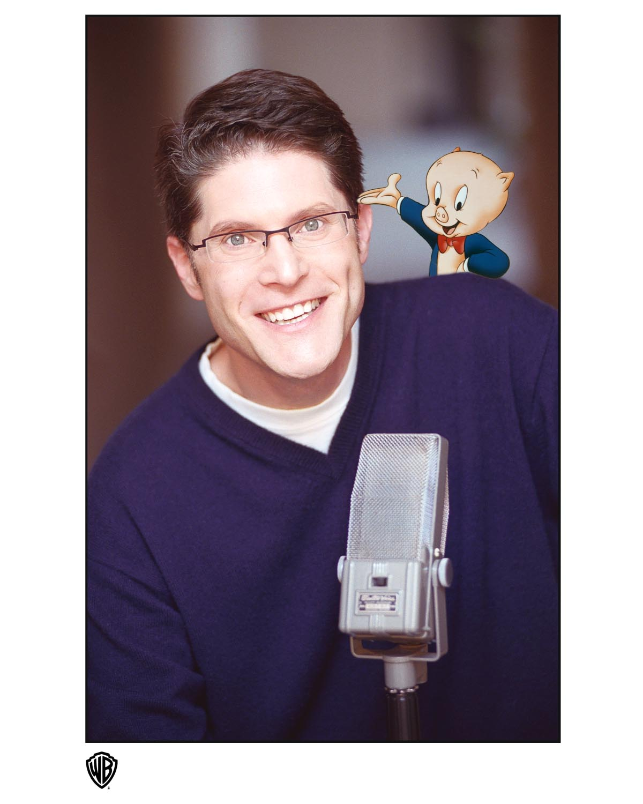
BIO

Bob Bergen moved to Los Angeles from Cincinnati when he was 14. Actually, he had no choice. His Dad took a job in LA and relocated the family. But LA is where he wanted to be. As a kid, Bob spent endless hours watching and taping cartoons, imitating voices as well as creating characters of his own. His dream was to voice The Looney Tunes, and in particular Porky Pig. Bob's idol was Mel Blanc, and he worked day and night trying to perfect eh-puh-peh-eh Porky's famous voice. To his parents dismay, he spent more time working on voices than he did at his school work, though I think they've forgiven him by now.

Soon after arriving in LA, Bob began investigating how to get into the world of doing voices for cartoons. He spent hours thumbing through the yellow pages, calling every animation studio in town, gathering information on how to break into the voice-over field. Hanna Barbara referred him to Bob Lloyd, who at the time had the only voice casting office in Los Angeles called The Voicecaster. Lloyd referred him to Daws Butler, a legend in animation and well known as the man behind the voice of Yogi Bear, Huckleberry Hound, Elroy Jetson, and Snagglepuss, to name a few. Daws taught a weekly voice-over workshop, and invited Bob to join the class. Bob also studied voice-over with anyone and everyone in LA offering a workshop, including Louise Chamis, Michael Bell, Brian Cummings, and Dave Madden. For the next several years Bob was never out of a class, studying voice-over, as well as improv and acting. He even got the chance to watch his idol, Mel Blanc record a project for Warner Bros.

When he was 18, a good friend of the family had Casey Kasem send Bob an autograph picture for his high school graduation. Bob sent Casey a thank you note, stating he wanted to do voices for cartoons and included his phone number. To his shock Casey phoned Bob and offered his assistance. Casey requested Bob make a home made demo of as many voices as he could. Bob sent Casey a tape of 85 voices which Casey, in turn, gave to Don Pitts, a voice-over agent and one of the nicest guys in the biz. Don signed Bob, and at 18 he was set up with his first agent. Not long after, Bob booked his first cartoon, Spiderman, and His Amazing Friends. He continued his studies with Daws Butler, and for the next 5 years slowly built up his voice-over resume with a variety of cartoons and commercials. To make ends meet, he worked as a tour guide at Universal Studios.

At the age of 23 Bob was able to leave Universal and work full time as an actor. His resume consists of 100s of cartoons, commercials, promos, radio imaging, live award show announcing, and interactive games. In 1990, Bob's dream came true when he joined a handful of actors who share the job of voicing The Looney Tunes. Over the years, Bob has voiced Porky, Tweety, Marvin the Martian, Henry Hawk, Sylvester Jr., and Speedy Gonzales in a variety of feature films, albums, toys, games, and television series', including the 2 time Emmy nominated series Duck Dodgers, in which Bob received an Annie Award nomination as best voice performer in a television series. In 1991 Bob was asked to play Sylvester, Jr., for a radio program called Mrs. Bush's Story Time, hosted by First Lady Barbara Bush. Soon after he was thrilled to be invited to a reception at the White House in appreciation for his participation in Mrs. Bush's literacy program.

Bob added game show host to his resume after landing the job of MCing Jep!, the kid's version of the classic game show Jeopardy!. For ten years Bob worked as the grandstand host at the annual Hollywood Christmas Parade. His job consisted of spending two hours prior to the parade warming up an audience of literally hundreds lined up and down Sunset Boulevard, entertaining, schmoozing and getting everyone in the Christmas spirit. Throughout the parade he had the privilege of interviewing some of Tinseltown's biggest stars as they traveled down the streets of Hollywood in floats and vintage cars. The Grand Marshall in Bob's first parade was James Stewart and Bob was honored to have the opportunity to meet and interview this legendary actor. Over his years with the parade Bob got the chance to interview some of Hollywood's biggest stars including Halle Berry, Sammy Davis Jr., Ed McMahann, Steve Allen and Mickey Rooney to name a few.

Bob was invited to teach his animation voice-over workshop at Judy Carter's California Comedy Conference in Palm Springs. This whirlwind weekend consisted of up and coming comics showcasing to various show biz movers and shakers. Through connections he made at this conference, Bob put together a one man show. After a one time "trial" performance in Burbank, he was asked by Ken Kragen, who managed Kenny Rogers, to be the opening act for Rogers' summer tour throughout California and Oregon. Upon returning from the tour Bob showcased his one man show at the Ice House in Pasadena and The Whitefire Theater in Sherman Oaks. Producer Ed Gaynes offered to produce the show commercially at the Whitmore-Lindley Theater in NOHO. Bob Bergen, Not Just Another Pretty Voice opened to great reviews and ran for 3 months. It was revived again in 2007, playing on a Royal Caribbean cruise to Mexico, as well as Las Vegas, and a 6 week run at The Stella Adler Theater in Hollywood. A new version entitled Bob Bergen: So, Here's The Deal is currently taking bookings in theaters throughout the country. In 2008 Bob began his 21st year teaching his animation voice-over workshop in Los Angeles as well as weekend intensives throughout the US and Canada.

Bob has been an active member of The Academy of Television Arts and Sciences since 1994, He's a 2 time volunteer Big Brother, and was honored as the 2007 Jewish Big Brother of the Year.

